- Copy BPC_FFWallRun to your project folder in Explorer
- Add a branch after your IA_Move input and before the Add Movement Input to use the input values of the blueprint component
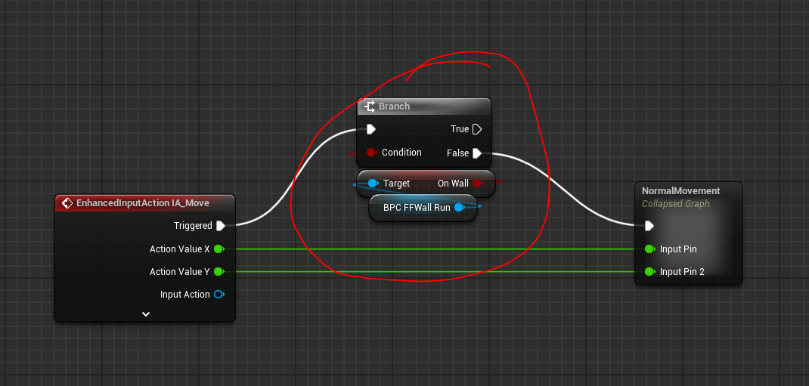
- In your animation blueprint, change ground speed to get vector length instead of vector length XY
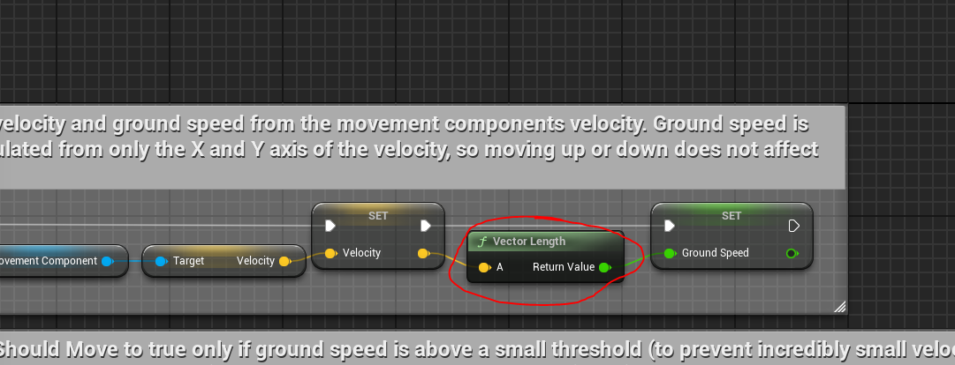
- Set the control options of your choice by setting the variables in the component. Each variable has a description explaining what it does and what else needs to be toggled
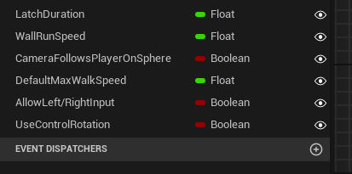
- Optional: Set animations to trigger based on Booleans
- OnWall & OnSphere – General move/walk/run etc.
- Hit – Landing animation
- Replace Jump after pressing shift and set your own animation to get to a wall

